A MAGNIFICENT CELEBRATION OF
THE WORLD’S MOST IMPRESSIVE SPANS

AN UPDATED & EXPANDED 20TH ANNIVERSARY EDITION

FROM THE BEST-SELLING AUTHOR OF SKYSCRAPERS AND

ONE WORLD TRADE

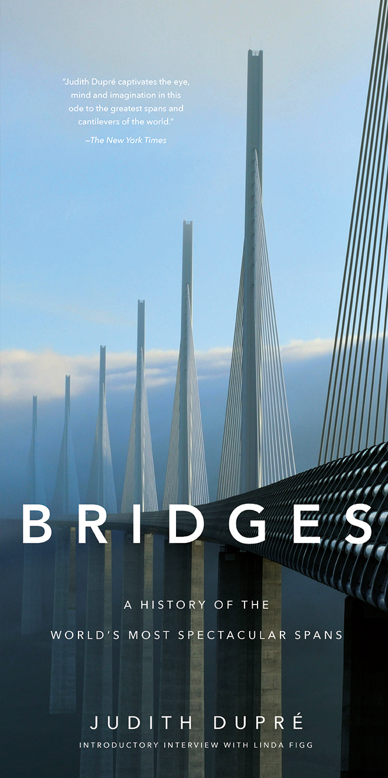

“Judith Dupré captivates the eye, mind and imagination in this ode to the greatest spans and cantilevers of the world.” – The New York Times, 1997

This visual history of the world’s landmark bridges is revised and expanded since it was first published twenty years ago, with all-new photos and essays featuring cutting edge work by today’s international superstars of architecture and engineering. Spanning two-thousand years of technological and aesthetic triumphs, BRIDGES (Black Dog & Leventhal; November 7, 2017) by best-selling author Judith Dupré, stands as the most thorough, authoritative, and gorgeous book on the subject.

With its dynamic design and oversized format, the book is as dramatic as the structures it celebrates. Breathtaking photographs capture the bridges' details as well as their monumental scale; location maps and architectural drawings invite you behind the scenes as new bridges take shape; and lively commentary on each span explores its historical context and significance. Throughout, informative profiles, sidebars, and statistics make BRIDGES an invaluable reference as well as a visual feast.

Technological advances, structural daring, and artistic vision have propelled the evolution of bridge designs around the world. The last twenty years has seen the construction of masterpieces such as the Zakim Bridge that changed the city of Boston; Gateshead Millennium Bridge in England, a pedestrian tilt bridge that closes like an eye when it is raised; the Millau Viaduct in Tarn Valley, France, now the tallest cable-stay bridge in world; and the 102-mile Danyang-Kunshan Grand Bridge in China, the longest in the world. This all-new twentieth-anniversary edition features profiles on these amazing spans and on beloved landmarks, such as the Golden Gate and the Brooklyn Bridge, as well as thematic chapters on new lighting technologies, military bridges, and bridges in the movies.

About the Author:

Judith Dupré, New York Times bestselling author, has written many books about architecture, including Skyscrapers, One World Trade Center, Churches, and Monuments. A National Endowment for the Humanities Public Scholar, she consults on large-scale infrastructure projects and lectures globally on creativity and the built environment. Visit judithdupre.com and OneWTCBook.com.

Linda Figg is President/CEO of FIGG Bridge Group, an international family of companies that designs, builds, and finances landmark bridges. With construction values totaling over $14 billion, FIGG’s award-winning bridges are in 42 states and 6 countries. Linda is one of few women in the world to direct a major bridge company.

BRIDGES
A History of the World's Most Spectacular Spans
By Judith Dupré

November 7, 2017 | Hardcover | $29.99 | 9” x 18” | 176 pages | 9780316507943

For more information about BRIDGES or to schedule an interview with Judith Dupré, please contact Kara Thornton at 212-364-0537 or Kara.Thornton@hbgusa.com

